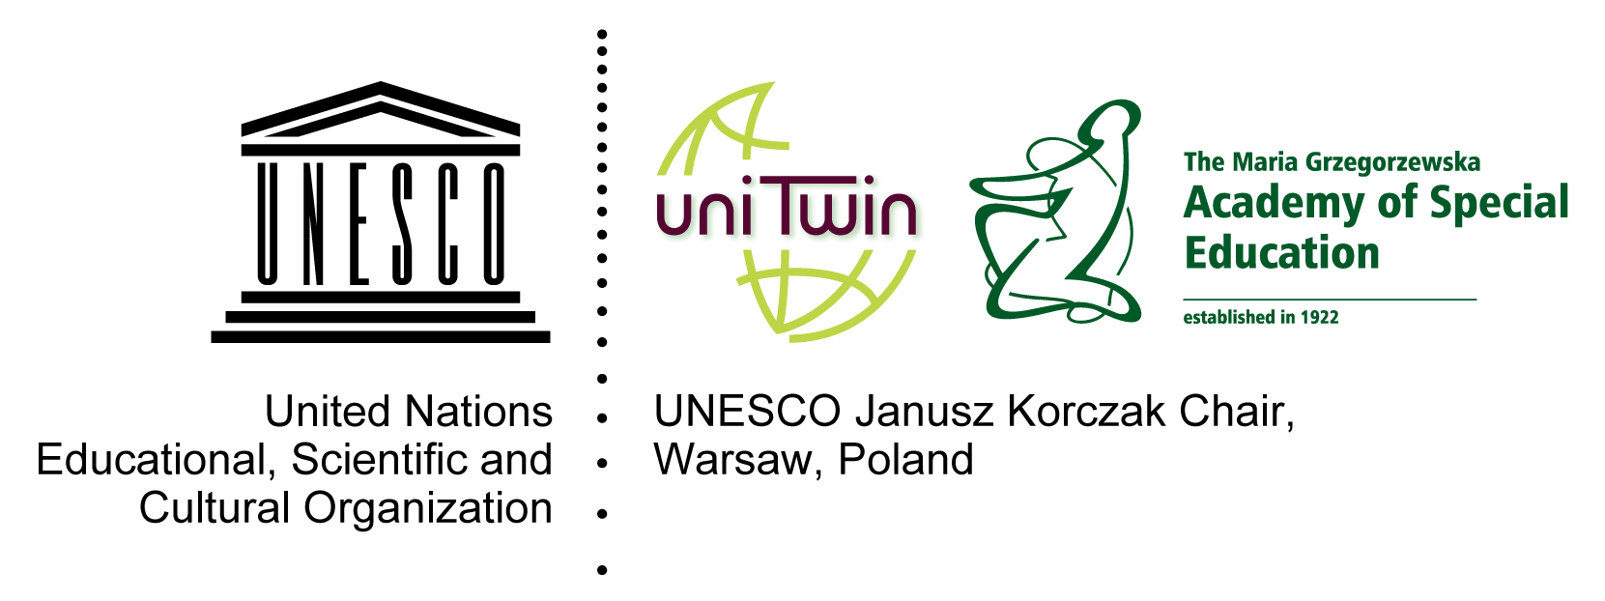

7th International Summer School
Psychological and educational support for pupils/students with diverse needs
15 – 25 September 2013
organised by
the UNESCO Janusz Korczak Chair
at the Maria Grzegorzewska Academy of Special Education
in cooperation with the Polish National Commission for UNESCO
Institute of Developmental Facilitation and Education
Institute of Therapeutic Pedagogy
Academy of Special Education, Szczęśliwicka Str., 40, 02-353 Warsaw, Poland

REPORT
The 7th International Summer School “Psychological-pedagogical support for students with diverse needs” was held between 15-25 September 2013. Academics, post-graduate students and students- specialists in the area of psychology and pedagogy from Belarus, Iran, Kazachstan, Germany, Russia, Ukraine and Poland took part in the event. The participants represented the following foreign universities: Freie Universität Berlin, Kazakh National Pedagogical University- Abay, Maksim Tank Belarusian State Pedagogical University, Kamenets-Podilsky State University, Herzen University - St. Petersburg, Kazan Federal University, Yanka Kupala State University of Grodno. The Polish participants were post-graduate students from the Academy of Special Education as well as a representative of the Foundation “Closer to a Child”.
The Summer School program (in the attachment) included lectures, workshops and study visits. A number of meetings with academics from the Academy of Special Education were also planned within individual programs.
The term “students with diverse needs” covers a wide range of phenomena, problems and methods of solving them. The needs of students with intellectual dysfunctions vary from those of students with physical dysfunctions (hearing, sight, motor organs). There are separate groups of socially maladjusted students, children with specific learning difficulties (dyscalculia, dysgraphy, etc), refugee children (language communication), children suffering from trauma connected with natural disasters or wars, but also remarkably talented students. All these problems found their reflection in the content of lectures and the subjects of study visits. However, detailed discussions, becoming familiar with current curricula and methods of work with students was possible only through individual programs – Summer School participants' meetings with academics- specialists from the Academy of Special Education.
Within individual programs the Summer School participants visited educational institutions which realize in Poland the idea of inclusive education:
1. Multicultural Humanistic Secondary School under the patronage of Jacek Kuron in Warsaw, 31 Kłopotowskiego St.
2. Special Schools Complex – Early Development Support Complex in Warsaw, 44 Białobrzeska St.
3. Integrated Preschool no 209 in Warsaw, 26 Sienna St.
The meeting was also an opportunity to present publications of the Academy of Special Education, including journals with points awarded by the Ministry of Science and Higher Education: “Man – Disability – Society”, which include articles written by participants of previous editions of Summer School. Among the materials presented to this year's edition participants one should name:
1. A publication in English edited by prof. Ewa M. Kulesza – a collection of case studies authored by the participants of the 5th Summer School of Special Pedagogy, entitled ”Students with special needs – World experience”, Wydawnictwo Akademii Pedagogiki Specjalnej 2013.
2. “Man – Disability- Society” no for 2013.
3. „Special School” no 1,2,3 for 2013
At the end of the 7th International Summer School we asked the participants for a brief evaluation of the program and its realization. The opinions highlighted the diversity of subjects and an interesting structure of the program, expressed appreciation of the possibility to exchange experiences and compare systems of education as well as curricula in various countries. The visited educational institutions, where practical application of pedagogical theory was presented during meetings with the staff and lesson activities, were also positively evaluated. Positive assessment was also expressed for individual programs which provided the possibility to discuss issues connected with particular problems or academic specialties represented by the participants.
In their free time the guests were offered meetings with the staff of University of Warsaw Library and the Library of the Academy of Special Education, sightseeing in the Old Town, Lazienki park and Wilanów as well as Warsaw Rising Museum.

